Probabilistic DCF Implementation Playbook
A practical build guide for a reusable AI operated investment research system
8 October 2026
Build one complete research process for Diageo, record its forecasts before outcomes arrive, then prove that the same engine works for a second company. The system connects dated evidence, an executable operating model, joint fundamental forecasts, estimated value, reverse valuation and catalyst analysis. AI APIs perform extraction, interpretation, model proposals and review; numerical services perform estimation and calculation.
This playbook expands the blueprint into implementation tasks. Each component specifies what to create, how to operate it and what must work before moving on. The companion starter kit provides an offline numerical demonstration and reusable implementation examples. The demonstration uses synthetic inputs; its results are not Diageo forecasts. Live data connectors, paid API calls and deployment still need to be integrated and verified in your environment.
The complete AI investment process is evaluated forward. Historical numerical checks remain useful for components, but a modern language model replaying old news does not establish an uncontaminated trading record. Portfolio sizing, exit rules and broker orders remain outside this project. Engineering correctness is achievable early; forecasting reliability must be demonstrated as outcomes arrive.

1 Start with the smallest complete system
The first working release should ingest one company report, extract verified facts, reconcile a compact operating model, generate provisional joint forecasts, calculate a valuation distribution, solve a reverse DCF and save an immutable forecast record. A command line and Django admin are sufficient initially. Do not delay the first recorded forecast until a polished dashboard or every possible data feed exists.
Use five separate output objects: fundamental forecasts, estimated value distribution, price consistent operating cases, catalyst scenarios and prospective scores. Add a horizon specific market price distribution only when the catalyst and market response assumptions support it. Each object carries its as of time, model version, evidence IDs and limitations.

What to do first
1. Unpack the starter kit into a new project folder and run the offline demonstration and its tests using the commands in its README. Inspect the generated JSON and confirm that you understand the difference between predictive operating outcomes and estimated value uncertainty.
2. Create a private Git repository and a Python virtual environment. Commit application code, schemas, prompts and source metadata; keep credentials and licensed raw documents outside Git.
3. Register Diageo, its fiscal calendar, reporting currency, one security and its quote units. Use official source metadata for each. Choose one listing first so that currency and share conversions have a single explicit path.
4. Download the FY26 annual report, the relevant interim report and recent results materials. Start with a source manifest and verified tables before building a scraper.
5. Produce the first model through a manual run command. Make its provisional status visible. Archive every numerical forecast even if the valuation is not interesting.

Run the companion examples
From the unpacked starter kit, create and activate a Python environment as described in its README, then run:
python -m pip install -r requirements_offline.txt
python -m unittest discover -s numerical -p 'test_*.py' -v
python -m unittest discover -s api -p 'test_*.py' -v
python numerical/statistical_demo.py
The checks cover numerical mechanics and API mocks. They do not make paid API calls, estimate Diageo parameters or demonstrate a forecasting edge. The API smoke-test script is a separate explicit command requiring credentials and a chosen model.

Decisions that should be fixed now
Decision | Starting implementation | Why
Core application | Python and Django with one research app | Fits an auditable financial database and gives you administration immediately
Database | PostgreSQL from the first concurrent worker | Supports transactions, constraints and row locks used by publication
AI interface | A thin provider adapter with typed responses | Prompts and models can change without rewriting the financial engine
Jobs | PostgreSQL job and outbox tables with one worker first | Keeps the first system small while making jobs recoverable
Numerical model | Compact scenario mixture with joint driver uncertainty | Exposes the assumptions that limited data cannot yet estimate precisely
Files | Local object directory first, object storage in deployment | Preserve originals and hashes without embedding large files in database rows
UI | Django admin, then a company research page | Focus initial engineering on evidence and calculations

A durable workflow engine such as Temporal becomes useful when orchestration, retries and parallel company coverage exceed the simple worker. Its activity replay model still requires idempotent business actions. Do not operate two competing schedulers over the same production state.

2 Understand the architecture and its boundaries
The shared platform owns storage, identifiers, jobs, API access, numerical interfaces and evaluation. A sector adapter owns economic vocabulary, equation templates, source mappings and valuation conventions. A company configuration supplies actual regions, disclosures, fiscal periods, overrides and securities.
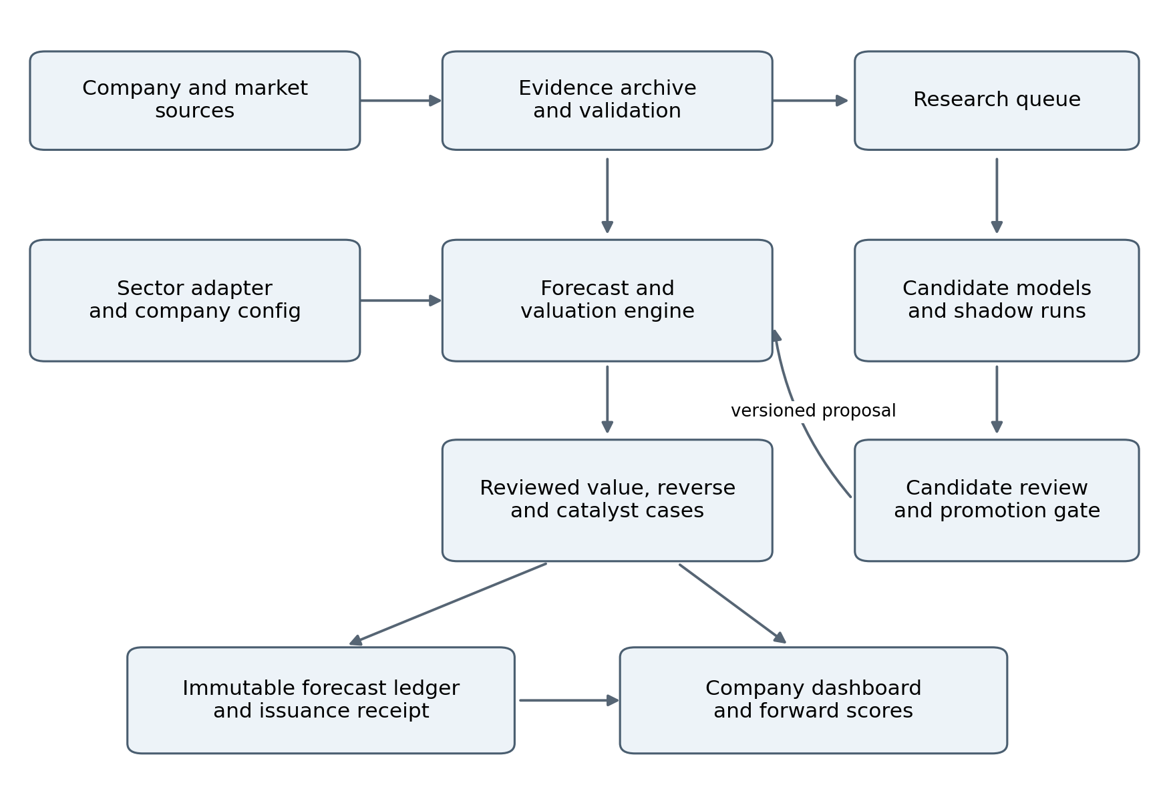
Figure 1 Shared infrastructure and controlled model improvement
The diagram shows data ownership as well as flow. Research can propose a candidate model, but production publishes only a validated run against an explicit model version. The forecast ledger records issued numerical outputs independently of the dashboard, so a later explanation or chart change cannot rewrite a forecast.

Create these modules
Module | Main responsibility | First public function or service
registry | Entities, securities, calendars, definitions | resolve_company and resolve_security
evidence | Originals, provenance, observations, revisions | archive_source and freeze_evidence
accounting | Period mapping and financial reconciliation | reconcile_period
model_engine | Compile approved equations and project accounts | compile_model and project_fundamentals
inference | Fit parameters and apply measurement updates | fit_parameters and update_state
valuation | Expected cash flows and current equity bridge | value_company
expectations | Price consistent cases | solve_required_driver
catalysts | Event observations and candidate market revisions | simulate_event
agents | Provider calls, schemas, tools and attempt logs | run_agent
workflows | Recoverable jobs and publication | run_company_update and publish_run
evaluation | Immutable predictions, outcomes and scores | issue_forecast and resolve_target
research | Candidate models and promotion evidence | register_candidate

A module can initially be a Python file. Create a new service only when isolation or scaling requires it. Financial calculations should be callable without an LLM or web server, which makes them inexpensive to test and reuse.

Scaffold the application
The following commands are for a Linux shell, including WSL on Windows. Use Python 3.12 for a consistent starting environment. The starter kit contains installation requirements for the offline example separately from these proposed application dependencies. Django 5.2 is a deliberate release family; install its current compatible patch and record the resolved environment. [S1]
mkdir probabilistic-dcf
cd probabilistic-dcf
python3.12 -m venv .venv
source .venv/bin/activate
python -m pip install --upgrade pip
python -m pip install 'Django>=5.2,<5.3' 'psycopg[binary]>=3,<4'
python -m pip install openai pydantic numpy scipy httpx
python -m django startproject config .
python manage.py startapp research
python -m pip freeze > requirements.lock.txt
Configure PostgreSQL through environment variables, add research to INSTALLED_APPS and use UTC internally. The reader interface can display Europe/London time. Store secrets in environment configuration or a secret manager. Do not commit a real API key or a database password. Run the application's migrations and tests after defining the models below; the scaffold alone has no forecasting functionality.

3 Define the database and provenance contracts
Use normal relational columns for identities, timestamps, statuses and relationships. Use JSON fields for versioned model specifications and arrays of diagnostics. Preserve original documents and larger simulation arrays outside PostgreSQL, referenced by immutable hashes and paths.

Create the core records
Record | Required fields beyond its ID | Constraint to enforce
Company and Security | Entity, exchange, symbol, reporting and quote currency, quote unit, share mapping, effective dates | A quote cannot enter valuation without a resolved security and unit
FiscalPeriod | Start, end, fiscal year, period type, reporting perimeter | One canonical definition per company and period version
SourceDocument | URL or provider ID, bytes hash, published time, received time, revision parent, license class | Same bytes do not create a second raw document
Observation | Metric definition, decimal value, unit, entity, region, period, source span, vintage, verification state | Approved input references a real source or a recorded derivation
EvidenceClaim | Passage, speaker, driver links, novelty cluster, interpretation, contrary evidence | A claim never masquerades as a reported number
ModelVersion | Sector adapter, equations, constraints, prompt/schema versions, activation time | An activated specification is immutable
StateVersion | Model ID, base generation, parameter IDs, applied evidence events | Evidence cannot be applied twice within a state lineage
Run | Frozen input manifest, base state, job ID, seed, hashes, status, diagnostics | A run references one coherent input snapshot
Forecast and Receipt | Target, horizon, distribution reference, completion time, immutable hash, issuance receipt | Issued content cannot be edited in place
MarketSnapshot | Security, timestamp, price type, bid/ask, FX direction, rates, dividends | Stale or incompatible quotes cannot silently become current
OutcomeVersion | Target, first public availability, first release value, later revisions | Restated outcomes never replace the original scoring target silently
Job and Outbox | Idempotency key, lease token, attempts, due time, status, published generation | A repeated delivery cannot duplicate a committed update

Use UUIDs for internal IDs and explicit version numbers for schemas. Monetary source facts can use Decimal; simulation arrays normally use float64 after validated conversion. Reject nonfinite values. Define percentage inputs as decimals, and keep percentage point bridges as a separate unit.

Handle time correctly
Keep event period, source publication, system receipt, validation completion and forecast issuance as different fields. An old period may be restated today. An article published earlier may reach your system late. For your operational information set, use the later of publication and receipt, plus validation status as known at the run cutoff.
If publication time cannot be verified, record that uncertainty. Do not guess that a source was available at midnight. Outcome resolution should use the earliest verifiable public disclosure of the target, including an early trading update if it resolves the result.

Make the input snapshot reproducible
At run start, select the exact approved observation and evidence versions available at the cutoff. Store their IDs, definition IDs, source hashes and the selected model version in a manifest. Later approval of a previously unverified observation must not make it appear in an earlier run.
Save the actual AI outputs, fitted parameters, numerical seed, code commit and dependency lock hash. Exact replay uses those frozen outputs. Calling the same model again with the same prompt is a new inference, even at a low temperature.
Completion check: reproduce an archived run after revising a source. The original observations and forecasts must remain unchanged. Add an integration test that tries to substitute a newer observation and confirm that the snapshot loader refuses it.

4 Acquire the first Diageo evidence bundle
Diageo's FY26 accounts use US dollars and a 30 June year end. Its annual segment note reports net sales, cost of sales, marketing and other operating items for five regions and Corporate and other, with an exceptional item bridge. Its disclosed price/mix is the percentage point difference between organic net sales growth and organic volume growth. These definitions must be preserved in the adapter. [S2]

Download and register these sources
Source | How to use it first | Where to begin
FY26 annual report and financial statements | Segment accounts, cash flow, balance sheet, accounting definitions and adjustments | Diageo results centre or SEC filing in the source list
Relevant interim report | Half year operating detail and cash flow | Same results archive; preserve its original vintage
Recent results announcement and presentation | Organic bridges, guidance and disclosure context | Company results centre
Investor event calendar | Candidate disclosure dates and changes | Company investor calendar
Company published consensus | A dated comparison with your forecasts | Diageo consensus page; archive each PDF vintage
One permitted market feed | Quote, security metadata, FX and rate conventions | Provider selected and entitlement checked by you

A company published consensus PDF dated 11 September 2026 is available as a starting reference. The mean, minimum, maximum and contributor count are useful context. Analyst dispersion is not automatically an outcome distribution or a calibrated probability interval. [S3]
Use your own Visible Alpha export if you have continuing access and the permitted usage covers this workflow. Begin with a file importer before attempting an undocumented API. Store export time, metric definition, contributing estimate period and whether the number is reported or adjusted. Do not assume an old browser login grants API access.

Make the first connector simple
Implement a local-file importer with the same interface planned for web connectors. It accepts bytes, source URL, publication evidence and a document type. It computes SHA256, saves the original once, records receipt time and creates an extraction job. A subsequent HTTP connector should provide that same object.
For scheduled web retrieval, use timeouts, bounded retries, a descriptive client identity where required, conditional requests where available and response content-type checks. A PDF link returning an HTML sign-in page must not be accepted as a new annual report. Respect the source's permitted access and retention terms.

Maintain a source manifest
For each feed, record frequency, release lag, revision policy, geography, channel coverage, license scope, cost, parser type, affected drivers and freshness expectations. Start with sources you can actually access. A missing commercial dataset is a coverage gap, not a licence to invent an observation.
A public candidate for later US spirits work is TTB monthly industry data. It is not company-specific consumer sell-through, and its publication and revision behaviour must be modelled. Check the source's current completeness before treating a missing entry as evidence. [S4]
Completion check: import one report twice and obtain one underlying evidence event. Import a revised report and obtain a new version linked to the old one. Simulate a failed fetch and verify that the existing forecast stays visible with a stale-source flag.

5 Extract facts and reconcile the accounts
Parse machine-readable tables first. For PDFs, preserve page numbers and retain the page image for difficult tables. Send bounded text or table sections to the extraction agent; include the company ID, period definitions and a whitelist of metric IDs. The output contains a raw source value and the normalized value, never just a summary paragraph.

Extraction procedure
1. Segment the source into meaningful sections such as segment note, income statement and cash-flow note. Give each section a stable ID.
2. Request typed observations with source spans and missing values explicitly represented as null. Keep a separate collection for management statements and inferred claims.
3. Validate that cited passages exist, values can be located in the relevant table, units are supported and periods match the supplied registry.
4. Reconcile totals and signs in code. Send only unresolved discrepancies to an accounting agent for a proposed explanation or mapping.
5. Approve verified observations, or retain the issue and block dependent outputs. During initial onboarding, inspect the small set of valuation-critical mappings yourself.
Automated extraction can scale after these mappings are established. A correct JSON shape is not verification of a financial fact.

Concrete accounting checks
Use a positive-expense convention inside the operating model, while preserving the original source sign. Reconcile net sales minus COGS to gross profit, then subtract marketing and other operating expenses to reach operating profit before the chosen adjustments. Keep Corporate and other as an explicit node. Maintain a separate bridge to reported operating profit and to cash expenditure on exceptional items.
For additive flow measures, derive the second half as full year less first half only when definition, perimeter and vintage match. Do not subtract growth percentages. Half year margins are ratios of the corresponding period totals; full year margin is a sales-weighted result. Closing balance-sheet values are stocks and cannot be added across periods. Weighted-average share counts require their own treatment.
Where a period's data are unavailable, leave the value missing and either forecast at a coarser frequency or use an explicit allocation estimate. Do not fabricate historical quarters from annual totals and later score forecasts against those allocations as if they were reported outcomes.

Build the review fixture
Select a small source-linked fixture covering group net sales, segment net sales, COGS, marketing, operating profit, capex, inventories, debt and share counts. Include at least one restatement, one missing field and one percentage point bridge. These cases should be manually verified once and reused as extraction regression tests when prompts or models change.
Completion check: every model input has a verified source or a transparent formula. Rounding tolerance is documented in source units. A reconciliation difference larger than that tolerance opens an issue; it is never absorbed by a hidden plug. FY26 comparative-volume changes and excise/COGS reclassification require a definition-version bridge before comparable periods are derived. [S2]

6 Compile the first consumer operating model
Build an adapter from reusable calculation blocks. A model-building agent chooses blocks and parameter links; Python evaluates only approved operations. Start with a registry of functions such as grow_level, add, subtract, multiply, sum_regions and ratio. This is faster and safer to implement than a fully general equation language.
A ModelSpec node contains an ID, operation, parent IDs, unit, frequency, parameter references and support constraints. Topologically sort the graph. Reject missing parents, within-period cycles, incompatible units and unregistered operations. Never evaluate arbitrary expression strings from the LLM with Python eval.

Define the financial rows
Block | Starting rows | Practical implementation
Regional operations | Net sales, organic volume, disclosed price/mix, FX/perimeter bridge | Keep the organic reporting bridge distinct from economic unit-price assumptions
Regional costs | COGS, marketing, other operating items, operating profit | Anchor disclosed totals; estimate hidden cost drivers with labels
Group operations | Regional sum, Corporate and other, group adjustments | Reconcile to chosen adjusted and reported definitions
Cash generation | Cash operating tax, D&A, capex, operating working capital, exceptional cash costs | Separate noncash adjustments from actual spending
Investment | Maintenance and growth investment, inventory requirements | Tie investment to operating activity and growth
Equity bridge | Net debt, nonoperating assets, other claims, shares | Apply one consistent claim and currency convention

For Diageo's disclosed organic bridge, calculate organic net-sales growth as organic volume growth plus disclosed price/mix in percentage points. If you separately model actual unit prices and product mix, translate that economic model into the disclosure definition before comparison. The starter numerical demo uses a generic multiplicative volume and unit-price identity; it is deliberately not the Diageo reporting bridge.

Implement costs without false granularity
Begin with observed COGS and marketing/other-cost ratios, then split costs into fixed and variable components only where evidence supports it. Treat undisclosed splits as parameters with uncertainty. A first COGS driver model can combine volume, unit-cost inflation and a lagged productivity term. Marketing can depend on revenue plus explicit strategic spending scenarios. Fixed overhead can grow with relevant wage or general inflation assumptions.
Treat maturing stock separately from ordinary operating inventory. A first schedule tracks production additions, releases to COGS and FX/perimeter changes, with unknown components explicitly estimated. Include impairments and other noncash changes separately, and reconcile the cash investment in working capital exactly once. Avoid forcing long maturation into a short DIO cycle. Diageo's aged inventory makes a same-month spot commodity price an inadequate cost proxy. Represent a lag kernel or inventory-cost state only after you have evidence for its timing; otherwise show a range of lag assumptions. An observed current commodity fall need not immediately improve reported gross margin.

Keep cash flow and claims coherent
Choose and document a lease policy. For example, a financing treatment includes lease debt in the equity bridge and handles right-of-use investment and depreciation consistently in FCFF. An operating treatment reconstructs operating lease expense and excludes lease debt. Implement one policy; do not combine pieces of both.
Separate operating taxes from a reported effective tax rate distorted by financing or exceptional items. Use current period-end shares for a current equity-value-per-share bridge, with a deliberate treatment of dilution; weighted-average EPS shares are not automatically the correct denominator. If cash flows include fully consolidated subsidiaries, account for noncontrolling claims consistently. Keep associate investments outside FCFF unless their cash contribution is modelled explicitly.
Completion check: the model reproduces approved historical totals and passes targeted stresses. A volume decline should transmit through sales, variable costs and working capital consistently. A cost cut requiring restructuring cash must not create free cash flow without that cash cost.

7 Estimate the initial joint distributions
Start with a model whose parameters you can explain. Do not begin by asking AI for a mean and standard deviation for every spreadsheet cell. The forecast specialist proposes a DistributionSpec; numerical tools estimate its parameters where data permit.

Build a parameter register
For every uncertain parameter record its economic meaning, unit, time persistence, parent factors, support, estimation basis, data vintage, scenario dependence and sensitivity range. Mark the basis as estimated, pooled, external or judgmental. Record which parameters are sampled once per trajectory and which represent recurring shocks.
Use three layers in the first implementation: a small set of structural scenarios, persistent parameters within each scenario, and joint operating shocks within a path. Scenario weights are provisional until their behaviour can be evaluated. Changing weights is a documented model update, not an invisible editorial choice.

Estimate what the observations can support
1. Build comparable time series with consistent definitions and periods. Keep source revisions explicit and avoid mixing organic and reported growth.
2. Fit a simple reference model first, such as a recent level or trend with a pooled error scale. For sparse company histories, pool selected parameters with comparable businesses while retaining company effects.
3. Use a small set of economically motivated predictors. Strongly shrink uncertain coefficients toward a reference value and preserve coefficient uncertainty. Few observations cannot identify a large driver network.
4. Estimate residual dependence using common economic factors or a regularized covariance. Check positive semidefiniteness before sampling. Do not assume observed correlations are causal effects.
5. Stress parameter uncertainty, scenario weights, lags and structural alternatives. Widen uncertainty when the available evidence cannot distinguish mechanisms.
Historical fit informs these numerical components. It remains vulnerable to feature selection and regime change, so label it diagnostic and register the future comparison before using results to claim predictive improvement.

Implement the first sampler
Draw a scenario, persistent parameters and common demand/cost/FX factors. Generate local residuals conditional on those factors. Transform bounded variables when needed, for example with a logistic mapping for a constrained ratio. Apply the financial graph to calculate dependent rows. Check support and accounts for every path.
Avoid silently clipping an invalid draw and treating the result as a sample from the original distribution. Correct the distribution design or report the excluded support. Some economic states, including negative margins, are valid and should not be eliminated merely because they are inconvenient.
The companion numerical module demonstrates persistent parameters, shared shocks, conditional valuation and mechanics tests with synthetic data. It does not estimate Diageo's parameters. Replace its fixture through the verified data and parameter register, not by changing a ticker label.

Add mixed frequency estimation later
A later extension can infer a monthly latent demand state from weekly or monthly indicators and periodic company disclosures. The measurement equation must aggregate monthly levels or flows according to the disclosure definition and model release lags, geographic coverage and noise. Do not average monthly growth rates to manufacture quarterly growth. Missing observations skip their measurement update. They do not become zeros. This follows established nowcasting methods, but indicator usefulness remains a company-level forecasting hypothesis. [S5]
Completion check: inspect prior predictive paths before fitting. Check realistic magnitude, coherent dependence, persistence and tail behaviour. Compare several seeds and draw counts to distinguish numerical instability from wide economic uncertainty.

8 Update the model when evidence arrives
Register each source event once. Route it to affected drivers using metric definitions and exposure maps. The update agent receives only the new evidence plus the relevant existing state and returns an UpdateProposal with direction, mechanism, horizon, novelty, contrary evidence and a registered update-method ID.

Quantitative updates
Begin with a simple measurement relationship for a chosen proxy. In the scalar Gaussian case, a latent state has prior mean m and variance P; a measurement is y = h times the state plus noise with variance R. The numerical update uses the innovation y minus h times m and a gain based on P, h and R. The executable gaussian_update function in the starter kit implements this calculation. Estimate or justify h and R; neither can be inferred from the LLM's confidence score.
For correlated measurements use a joint measurement update with a covariance matrix, or select one representative measurement. Reapplying a source event is prohibited by an idempotency constraint on the state lineage. A revised observation should rebuild from the appropriate earlier state or apply a registered replacement method; do not simply add it as another independent signal.

Qualitative updates
Management commentary can update a structural scenario or a bounded parameter range. Preserve the supporting passage and explicitly state the assumed mapping. Where no credible likelihood exists, publish scenario sensitivity instead of a precise posterior probability. A demand warning that only repeats already-ingested sales data is not a second independent demand shock.

Structural changes
Evidence of a new distribution channel, accounting perimeter or enduring category change can invalidate an existing relationship. Open a ResearchProposal and mark affected outputs. Production may widen uncertainty or run a provisional alternative immediately, while retaining the incumbent. A previously narrow distribution is allowed to become wider.
Completion check: an identical event does not change state twice. A revised event has the intended replacement effect. For comparable surprises, test sensitivity to measurement quality. A less informative measurement should reduce uncertainty less; a large noisy surprise can still move the mean more than an unsurprising precise observation.

9 Calculate value with explicit assumptions
The valuation service accepts a model state, expected operating forecasts, discount policy, terminal policy and equity bridge. It returns a typed result containing enterprise value, equity value, per-share value, sensitivity, invalid mass and Monte Carlo error diagnostics.

Implement conditional valuation
Use outer draws for uncertain persistent parameters, model choice and current state. Within each draw, average future operating shocks to estimate conditional expected FCFF, or use an analytic expectation where valid. Discount those conditional expected cash flows. The distribution across outer values represents uncertainty about estimated fundamental value under the represented assumptions.
Keep predictive cash-flow distributions as separate outputs. A set of realized twenty-year cash-flow paths is not a set of price forecasts for next year's option expiry. Where inner simulation is used, track its numerical error so it is not mistaken for genuine outer valuation dispersion. Increase inner draws until the reported valuation percentiles are stable enough for the stated decision precision.

Implement terminal and discount policies
The terminal policy should specify a stable margin, growth rate, return on incremental invested capital, reinvestment and required return. In a standard stable-growth model, terminal FCFF uses after-tax operating profit less reinvestment needed to support growth. Enforce consistency between growth and return on capital and require the discount rate to exceed terminal growth. [S6]
A simple initial valuation uses one transparent WACC policy and scenario sensitivity rather than independently sampling many loosely justified components. If discount rates vary by scenario, explain the economic basis and preserve dependencies. Avoid adding an arbitrary risk penalty for a specific loss already included in expected cash flows. Keep nominal/real and currency conventions aligned.
Use exact remaining-period cash flows for a valuation between reporting dates. The first version can value at a clearly labelled fiscal boundary while you implement that bridge. Do not label a fiscal-year-end valuation as today's value. A current-date model needs elapsed-period cash flows, current balance-sheet roll-forward and discount times in years. Midyear discounting is an optional convention, not a substitute for this date alignment.

Implement the equity bridge
Use the market snapshot date and a dated net-debt bridge. Convert USD estimated equity value into the security's quote currency using an explicit FX direction; convert major currency units to quoted minor units only once. If valuing an ADR, obtain the current underlying-share ratio and effective date from authoritative security information.
Do not reduce future shares for buybacks while retaining the repurchase cash. Distress states require a supported recovery/financing treatment; simply flooring negative equity DCF values at zero does not create a default model. Unsupported material tails block unconditional probability claims. Publish any supported subset as conditional and state omitted probability mass.
Completion check: verify a hand-calculated DCF, currency conversion and equity bridge. Increasing WACC should reduce value for the positive-cash-flow test fixture. Demonstrate terminal reinvestment, correct valuation date and sensitivity to material unsupported assumptions.

10 Solve reverse DCF questions
Use the same financial definitions and date convention for forward and reverse calculations. A reverse solve takes an observed price, one unknown driver, a permitted domain and a fixed draw of the remaining assumptions. It returns the required driver, residual error, solver status and all conditioning inputs.

Implement the solver
1. Pick an interpretable unknown, such as multi-year organic growth or a normalized margin. Parameterize its path and transition to the terminal state explicitly.
2. Define the numerical objective as calculated price minus observed price. Recalculate investment requirements whenever growth changes.
3. Evaluate the objective across the allowed domain. Use a bracketed root solver only on intervals with a sign change. Search multiple intervals when monotonicity is not established.
4. Return solved, multiple_roots_found, no_bracket_in_domain or solver_failed as explicit statuses. Reserve a proven no_solution claim for a domain where monotonicity or valid bounds establish it. A finite scan can miss roots. Keep residuals, failed-draw weights and economically implausible boundaries visible.
5. Repeat over matched nuisance draws such as margin paths, WACC and terminal policy. Compare your forecast and the required outcome using those same conditions.
A bracketed solver such as scipy.optimize.brentq is appropriate for a continuous objective with a valid sign-changing bracket. It does not establish that the model has only one root across an arbitrary domain. [S7]
The resulting distribution describes required outcomes conditional on your supplied assumptions. It is not a uniquely recovered market probability distribution. Add a growth-margin grid so alternative price-consistent explanations remain visible. Maintain an independent fundamental forecast; do not use a price-fitted prior and then describe agreement with price as independent confirmation.
Completion check: generate a price from a known synthetic parameter and recover it within tolerance. Test a price outside the supported valuation range and retain the no-solution result. Verify that matched-case comparisons do not silently change reinvestment or discount assumptions.

11 Turn catalysts into measurable information events
Register events that could resolve a specific disagreement. Scheduled results need a verified date; unscheduled events need a timing window and an explicit occurrence model. An event that happens but discloses nothing relevant is a valid outcome.

Define a CatalystSpec
Store event ID, source/date, disputed driver, observable disclosure, reporting definition, forecast distribution, market reference cases, information-update rule, no-information case and outcome resolution rule. Separate reported numbers, guidance and commentary because they can send different signals.

Implement the first event simulator
Use a narrow example: the next reported organic net-sales growth measure at a defined scope. Your physical forecast generates possible disclosures. Each candidate market baseline starts with assumptions consistent with the current price under an explicit discount policy. Update that baseline only with information the event reveals. Revalue its conditional expected future cash flows after the disclosure.
Report the distribution of estimated expectation revisions separately from actual traded-price responses. The price-response layer needs additional assumptions about recognition, required returns and residual market variation. Initially show sensitivity cases rather than claiming those probabilities are calibrated. A disclosure matching the prior mean can still reduce uncertainty and affect nonlinear valuation; it creates no automatic mean surprise.
Do not give a simulated market the full future realized cash-flow path. At the event date, subsequent years remain uncertain. Also, a result already expected by the candidate market baseline should not mechanically create an upward revision.
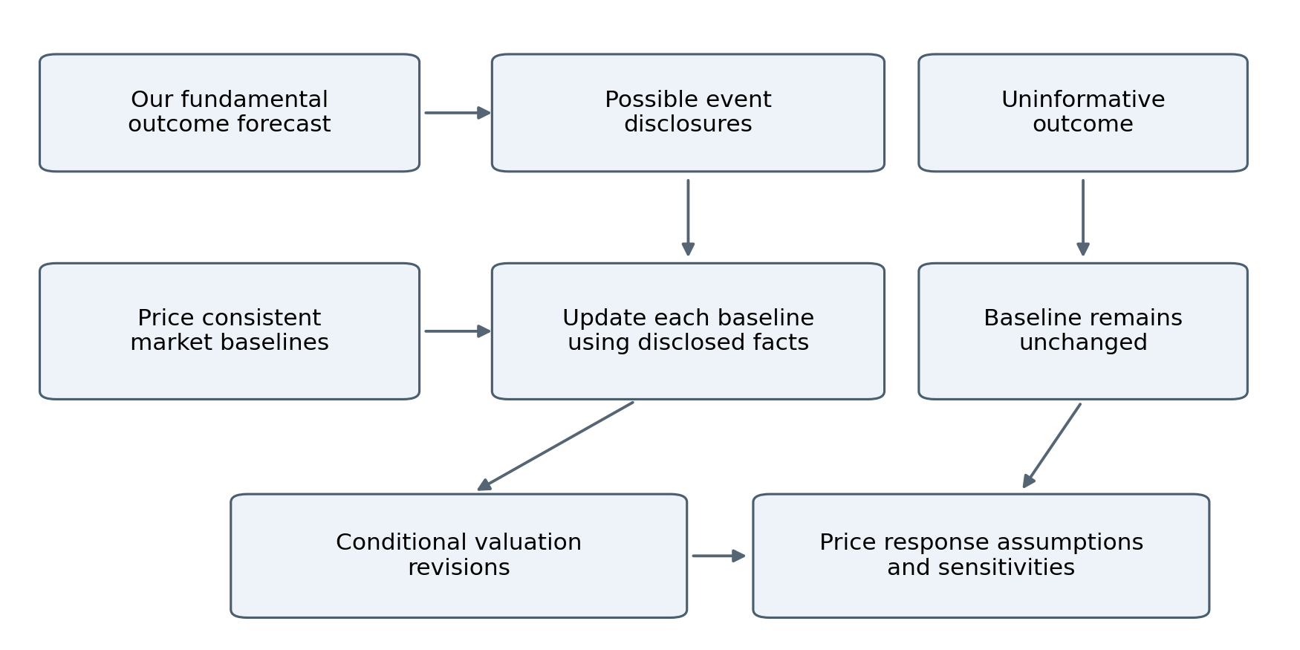
Figure 2 Disclosures update candidate market expectations

Validate event usefulness
Resolve whether the disclosure occurred, what it actually said and how well it measured the disputed driver. A narrow regional thesis may be weakly tested by consolidated results. Your event forecast can be accurate while its information impact is small. Record that distinction in the evaluation database.

Work through one numerical event
Synthetic illustration: a candidate market baseline has persistent growth with a mean of 2.0% and standard deviation of 1.5 percentage points. A release reports 4.0%, with assumed measurement noise of 2.0 percentage points. A normal observation model gives an update weight of 1.5 squared divided by the sum of 1.5 squared and 2.0 squared, or 0.36. The revised mean is 2.72% and the revised standard deviation is 1.20 percentage points. Revalue this conditional baseline. The prior, measurement noise and weights across alternative baselines remain judgmental unless supported by evidence. This is an expectation-update calculation, not a calibrated share-return prediction.
Completion check: the no-information case leaves the baseline unchanged, a precisely expected disclosure creates no automatic surprise, and later-period information is absent from the simulated event input.

12 Chain AI APIs through explicit contracts
Use a small provider adapter with four operations: create a typed response, execute an allowed tool request, record an attempt and return a validated result or a typed failure. The application owns the sequence and persistence. Conversation history is supplementary context rather than the authoritative company database.
Official OpenAI documentation supports parsing Responses output into Pydantic models and application-executed function calls. Strict schemas constrain shape; the business checks must still verify source support and accounting. Refusals, incomplete responses and transport failures require separate handling. [S8][S9]

Agent sequence and authority
Agent | Input bundle | Structured output | Allowed next action
Onboarding | Company sources and sector adapter | CompanySpec proposal | Registry validation
Extraction | Source sections and metric dictionary | Observations and claims | Source and unit checks
Accounting | Facts and reconciliation differences | Mapping or issue proposals | Reconciliation tools
Model design | Verified history and adapter | ModelSpec proposal | Compile and stress
Forecast design | Model, data and parameter register | DistributionSpec | Fitting and simulation tools
Evidence update | New event and relevant state | UpdateProposal | Registered update only
Expectations | Frozen forecasts and market quote | Reverse question set | Solver calls
Catalyst | Disagreement and event catalog | CatalystSpec | Disclosure simulator
Review | Locked run and diagnostics | Issue list | Request evidence or recalculation
Explanation | Approved results and provenance | User-facing text | Publish with the run

The onboarding and model-design agents do not run for every new quote. Routine jobs invoke only stages affected by new evidence. Different source sections can be extracted concurrently; dependent financial stages wait for validated inputs.

Start with a typed extraction call
The starter kit includes an API example, schema and a prompt. It is documentation-checked and requires your own live smoke test, credentials and a supported model choice before use. The example ObservationDraft is an interchange subset; the application adds original value text, document hash, availability timestamps and revision lineage before persistence. Keep model IDs in configuration. Test candidate models on the same extraction fixture, then pin the available snapshot where supported and record the returned model metadata.
The prompt must require exact evidence references, null for missing values, separation of facts/guidance/inference, and no remembered facts to fill source gaps. Treat instructions inside a source document as document content. Limit retrieved context to relevant immutable source IDs and include definitions directly in the bundle.

Concrete API call pattern
The following is a condensed excerpt of the adapter in api/api_examples.py. ExtractionResult and packet are defined by that module. The full companion adds refusal detection, evidence checks, attempt records and a persistence callback. No live call was made in preparing this playbook.
from openai import OpenAI

client = OpenAI(timeout=90.0, max_retries=0)
response = client.responses.parse(
model=configured_model_id,
instructions=extractor_instructions,
input=[{
"role": "user",
"content": packet.model_dump_json()
}],
text_format=ExtractionResult,
max_output_tokens=5000,
store=False,
)
A successful parse remains pending accounting validation. In production, supply the companion's record_attempt callback so the started attempt commits before the external call and the completed result commits afterward. Without the callback the example record is only in memory. A retry may duplicate remote API cost even when business-state commits are idempotent.

Tool execution contract
Tools accept IDs and typed parameters, not arbitrary SQL or arbitrary filesystem paths. Whitelist tool names, validate arguments, recheck entity/version permissions and record every request/result. A valuation tool returns a stored numerical result ID; it does not merely return a paragraph that another agent must re-interpret.
For function calling, return a result tied to the received call_id. Preserve required response items when continuing the model conversation. If several calls are returned, execute independently only when dependencies and write permissions allow it. The example supplies the extraction adapter and allowlisted dispatcher. Implement the bounded multi-round Responses continuation loop in the application; it is not supplied as a complete orchestrator. Production writes remain application-controlled.

Failure and cost controls
Persist an attempt before making the external call. Record request ID when available, output status, usage, elapsed time, prompt/schema versions and the actual result. Use one bounded retry policy; avoid multiplying SDK retries by a second large application loop. Transport failures, schema failures, incomplete outputs and failed business checks need different handling.
Allow a small number of targeted repairs with explicit validator errors, then quarantine. A failed extraction never becomes a zero-valued observation. Cache completed results by evidence hash, prompt/model/schema versions and task parameters where reuse is semantically valid. Track cost per document, company update and research candidate. Set global and per-job limits and stop a research task with a result, rejection or data gap.
Completion check: run the fixture through the selected API model. Force malformed evidence, missing fields, refusal/incomplete output and a tool timeout. Verify that each produces a recoverable state and that no failed result becomes an approved model input.

13 Make continuous execution durable
Use three initial triggers: new evidence, due freshness checks and newly resolved outcomes. A scheduler writes job rows; workers lease jobs, perform work and commit results. New documents create extraction jobs; changed observations create affected-company jobs; resolved outcomes create scoring jobs.

Implement a recoverable worker
Claim a job in a short PostgreSQL transaction using row locking and a unique lease token. Store a lease expiry and attempt number, then release the database lock before calling APIs or running simulations. Renew long-running leases. A replacement worker may reclaim an expired lease, but the old worker's token must no longer authorize a commit.
Freeze the model version, base state generation, relevant evidence generation, source cutoff and market snapshot. Write intermediate artifacts under the run ID. At publication, lock the company state briefly, verify the lease and compare the current model, state generation and relevant evidence generation with the run's base. Increment evidence generation whenever relevant accepted evidence changes. Reject or rebase a stale run. Insert the new state and output references atomically.
Django transaction.on_commit can wake a worker after a commit; it is not durable delivery by itself. Persist an outbox row inside the same transaction as the state change. A dispatcher retries outstanding outbox rows after crashes. Consumers use stable idempotency keys. [S10]
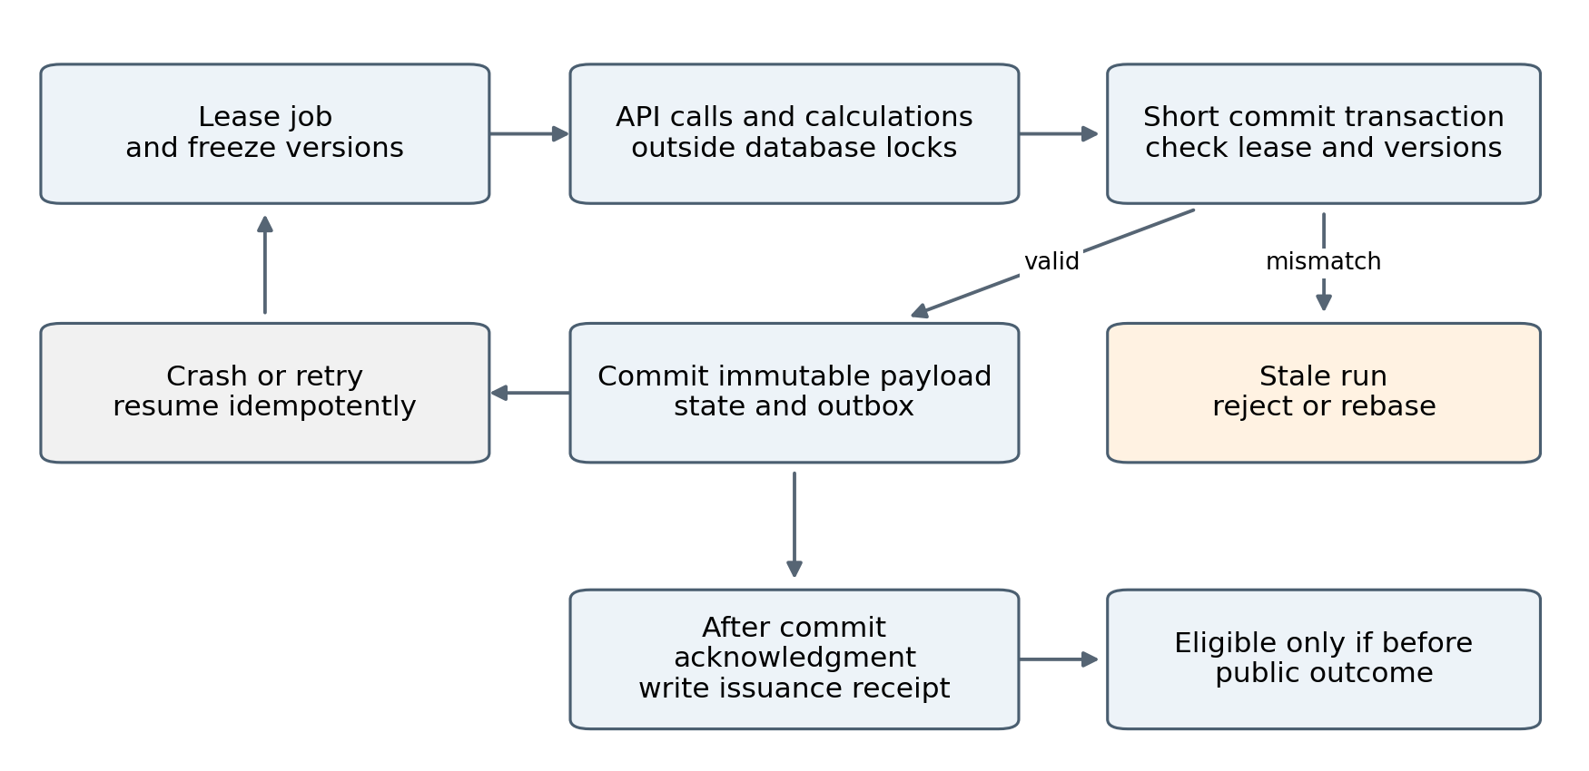
Figure 3 Durable publication and prospective issuance

Record issuance after durable commit
A timestamp assigned inside an open transaction does not prove that a forecast was committed before an outcome. Only after the forecast payload COMMIT has been acknowledged, obtain a new database clock_timestamp() value and persist a uniquely linked issuance receipt referencing its immutable hash. Do not backdate a missing receipt on recovery. Conservative late exclusion is preferable to an unverifiable pre-event claim.
Use the receipt as the internal prospective cutoff, with synchronized clocks and a documented timing margin around releases. If independent external proof is later required, add an append-only external timestamp or publication receipt. Hashes alone establish content identity, not when the content existed.

Move to durable orchestration when needed
When using Temporal, keep network calls and mutations in activities, make those actions idempotent and preserve activity outputs for workflow replay. Keep numerical code and schema versions compatible with in-flight jobs or deploy explicit workflow versions. Adding an orchestration product does not remove database concurrency and duplicate-delivery concerns. [S11]
Completion check: terminate a worker after extraction, after numerical calculation and after database commit. Restart it and verify one resulting state, one logical evidence update and a conservative issuance receipt. Run two company updates concurrently and prove that the older base cannot overwrite the newer one.

14 Evaluate the system prospectively
Define forecast targets before issuance. A target contains company, metric definition, scope, period, horizon, reporting vintage and the rule for selecting the realized value. For repeated forecasts of one result, use fixed evaluation lead times. Keep all other refreshes in the audit trail without counting them as independent outcomes.

Create baselines at the same cutoff
Issue a simple reference forecast, the production model and each registered candidate using the same available information. A consensus baseline needs its dated vintage and an explicit uncertainty model if it is to be scored as a distribution. Consensus mean alone is a point forecast.
Store the full forecast distribution or a reproducible sample and its representation. Use comparable numerical accuracy for scores. For continuous outcomes, CRPS assesses the predictive distribution; for a predefined binary event, use a Brier score. Check interval coverage and interval width alongside those scores. Proper scoring rules support honest probability forecasts, but finite samples still leave uncertainty. [S12]

Resolve and score outcomes
When a release arrives, determine whether it resolves the target exactly. Record the earliest public availability, initial value and subsequent revisions. First-release and restated targets are separate evaluation objects. Exclude a forecast whose issuance receipt is after first public resolution, even if your ingestion pipeline received the outcome later. Uncertain or unverified first-publication timing cannot support a validated pre-event claim; retain those cases as timing-unverified.
Score fundamentals, catalyst disclosures and market response separately. Intrinsic value and terminal growth do not resolve on a reporting date. Assess them through underlying observable forecasts, economic consistency and sensitivity; a share-price increase does not establish that every DCF assumption was right.

Compare candidates without selecting lucky winners
Register each candidate's mechanism, target, baseline and evaluation rule before new outcomes. Retain failed candidates. Use paired comparisons on the same company/event targets. Account for common sector and time shocks; many correlated company forecasts do not provide independent evidence.
Use fixed review windows and a subsequent confirmation window, or a suitable formal sequential procedure. Repeatedly checking a large candidate pool and promoting its best recent performer creates selection bias even without historical backtesting. Do not invent a universal threshold such as two good quarters. Report uncertainty and leave predictive superiority unestablished when evidence is insufficient.
Completion check: a deliberately post-release forecast is excluded, a restatement does not rewrite the first-release score, and repeated daily forecasts are grouped under the same underlying target. The starter demo includes mechanics for a distribution score; your database tests must cover timing and identity.

15 Operate a bounded AI research loop
Run research on a separate queue and separate write permissions. Agents can inspect forecast errors, retrieve permitted evidence and register candidate specifications. They cannot overwrite production or alter issued forecasts.

Use this research task contract
A task names the current weakness, proposed economic mechanism, measurable target, expected lag, necessary source, data availability date, baseline, extra complexity, cost limit and falsification condition. For example, a candidate may test whether distributor inventory measures improve shipment forecasts beyond retail demand indicators.
Require the agent to report rival explanations and what data would distinguish them. Historical fit can reject obviously useless ideas or detect implementation errors, but the complete AI candidate must issue new forecasts to establish prospective performance. A missing dataset should end in a documented data gap, not an invented relationship.

Prioritize work economically
Use valuation sensitivity to identify influential assumptions. Combine influence with uncertainty and the feasibility of obtaining informative data. Investigate a material uncertain margin recovery before optimizing an immaterial expense row. Where the value of information cannot be quantified credibly, use explicit qualitative priorities.
Allow structural hypotheses and operational bug fixes to follow different release paths. A verified sign or currency bug can be corrected with targeted tests and an impact report. A new predictive relationship needs forward comparison. Urgent structural adaptation can be labelled provisional and run alongside the incumbent.
Completion check: every active candidate has a bounded task and a future comparison; every promotion has an immutable rationale and version. A research agent attempting a direct production write must be rejected by application permissions.

16 Add instrument research when the horizon is supported
The first release can stop at fundamental value and conditional catalysts. Add an instrument comparison only after specifying the market-price horizon and information dynamics. Compare per-unit payoffs; capital allocation and exit rules remain outside this playbook.

Implement the data contract first
Each option quote needs underlying security, timestamp, expiry, strike, call/put, exercise style, contract multiplier, settlement, bid/ask, volume/open interest where available, dividends and corporate actions. Prices and FX must use the same security and units as the forecast. A stale midpoint is not an executable price.
For a European option evaluated at expiry, simulate its payoff under your physical terminal-price scenarios and compare with quoted cost using consistent financing and fees. For American contracts, dividends and early exercise matter; for valuation before expiry, remaining volatility and the option surface matter. If those inputs are absent, withhold that comparison.

Build implied distributions carefully
An option chain constrains risk-neutral future prices. Fit an arbitrage-consistent surface or curve using appropriate forwards, discounting, dividends and contract conventions before inferring a density. Raw American option prices must not enter a European density extractor. An exercise-style-aware model is needed before any European-equivalent conversion. Sparse strikes, wide spreads and extrapolated tails can dominate the result. Do not take noisy second differences of raw option quotes and call the output a robust probability distribution.
The risk-neutral distribution is not the market's physical forecast of sales growth, and a difference from your physical forecast may reflect risk premia. This distinction is central to interpreting option-implied distributions. [S13]
Completion check: known payoff identities and contract conversions hold. The module refuses an intrinsic-value histogram as an expiry-price forecast. A comparison states its horizon, forecast assumptions, executable quote and unsupported path features.

17 Build the interface and deploy one controlled service
The first user interface can be Django admin plus read-only company pages. Add five panels: forecast financials, estimated value and sensitivity, reverse DCF, catalysts and prospective scores. Every panel reads the same published run ID so that updated forecasts cannot be shown beside older assumptions.
Show last successful run, source freshness, quote timestamp, model version and provisional status. Let a user open each important assumption, its source and its revision history. Explain changes by controlled recalculations, not a reporting agent's invented causal story. If interactions make attribution order-sensitive, show that limitation.

Deployment procedure
1. Run the web process, one worker and one scheduler against managed PostgreSQL. Keep the worker independent of incoming web requests and machine sleep. Given your Django and Azure background, a familiar Azure deployment can host the web application, with a separately supervised worker and object storage.
2. Store credentials outside the repository, use least-privilege database roles and enforce authentication. Research tools receive restricted write permissions.
3. Back up PostgreSQL and source objects; test restoring one company and replaying a frozen numerical run. Version data definitions with the application.
4. Monitor failed jobs, lease expiry, source lag, API latency/cost, reconciliation differences, invalid simulation mass and forecast revisions. Alert on failures in the dashboard first.
5. Deploy with the scheduler paused, run migrations, check a stored fixture, start one worker, then resume jobs. Retain a previous executable version and last-good published state.
This is a proposed deployment topology, not a deployed service. Cloud product configuration, accounts, quotas and current prices must be checked when provisioning. Keep the first environment small; financial data entitlements and API volume can matter more than web hosting.

Budget from measured usage
Estimate daily API spend as documents times extraction cost, plus company updates times reasoning/review cost, plus bounded research tasks. Add data licences, storage and infrastructure separately. Measure tokens and cost on a small fixture; do not budget from an assumed fixed number of tokens per company. Increasing coverage should require a measured marginal cost and an observed source-quality level.
Completion check: stop the worker and see a clear stale status, restore it without duplicate updates, restore a backup, and reproduce a stored run. Confirm that no API key or licensed raw source is exposed in the public-facing interface.

18 Execute the build through deliverable gates
The table is an implementation order, not a requirement to spend months on one prototype. Work can proceed in parallel where dependencies allow. Each gate needs a demonstrable output; elapsed time alone is not progress.
Gate | Work product | Evidence that it is ready
A | Offline numeric core | Starter tests pass and outputs are understood
B | Registry and source bundle | Identity, currency, periods and raw documents are verified
C | Extracted financial history | Critical metrics reconcile and open gaps are explicit
D | Executable consumer model | Historical rows reproduce and stresses behave coherently
E | Provisional probability model | Joint paths, assumptions and numerical error are visible
F | Valuation and reverse tools | Hand fixtures, units, date alignment and solver cases pass
G | Forecast ledger and worker | Timely immutable forecasts survive retries and races
H | Second company | Reuse requires configuration and a limited adapter extension
I | Catalyst and research loops | Observable event targets and shadow candidates are registered
J | Market instruments | Horizon and contract requirements are supported

Start the ledger as soon as gate E can issue a defined forecast. Gates F and G can progress together. Source acquisition and generic schemas can run alongside the numerical core. Do not allow a downstream agent to consume an unverified upstream result as an approved fact.

Delegate coding work in bounded tasks
Use the task briefs in the starter kit one at a time. Each instructs a coding agent to read the current interfaces, implement one component, run the relevant checks and report changed files and remaining gaps. Supply small fixtures and acceptance criteria. The integrating agent owns schema compatibility and the combined run; parallel agents should not all modify the same database models or migration files.
Make the second company's onboarding a real test. It should reuse source provenance, forecasting interfaces, valuation orchestration, ledger and evaluation unchanged. Extend the consumer adapter only for genuine economic differences. New sectors may need different valuation methods; banks and insurers should not inherit industrial FCFF mechanics automatically.

First complete run to demonstrate
From a verified source bundle, run extraction, approval, model projection, provisional simulation, value calculation, reverse cases, review and issuance. Inspect the source-to-result trace. Then import a new, clearly relevant observation and confirm that only the intended drivers change, the prior forecast remains immutable and a new receipt is issued. That is the first repeatable research unit to scale.

19 Diagnose failures before expanding coverage
Symptom | Likely issue to investigate | Next concrete action
Narrow valuation range despite weak evidence | Parameter/model uncertainty omitted | Add competing mechanisms and persistent parameter uncertainty
Every article increases confidence | Duplicate or dependent evidence counted repeatedly | Inspect novelty clusters and measurement covariance
Large value increase with little investment | Growth and reinvestment disconnected | Reconcile incremental capital and terminal policy
Costs jump implausibly with spot inputs | Missing inventory or hedge lag | Compare lag mechanisms and source coverage
Good fundamentals but weak event forecasts | Disclosure does not reveal thesis or baseline already expected it | Rebuild observation and market-baseline cases
Old forecasts reappear on dashboard | Missing base-state or lease checks | Reproduce the race and repair publication transaction
Excellent forward score after many revisions | Late issuance, target mismatch or candidate selection | Audit receipts, release times and all candidate versions
No reverse solution | Price outside supported domain or incorrect conventions | Inspect units, equity bridge and allowed driver range
Agents agree but facts are wrong | Shared source or extraction error | Verify original table and deterministic checks
A second company needs a rewrite | Company assumptions embedded in common code | Move economics into the adapter and configuration

20 Sources and implementation references
These sources support specific technical capabilities, company definitions and methods. The proposed architecture and release gates are design recommendations. Check current provider availability, API schemas and data entitlements when connecting the service. Reference date is 8 October 2026.
[S1] Django 5.2 installation and database setup. https://docs.djangoproject.com/en/5.2/intro/install/
[S2] Diageo FY26 annual report, financial statements and definitions. https://www.sec.gov/Archives/edgar/data/835403/000162828026057527/dia045-arax2026annualrep.htm
[S3] Diageo consensus dated 11 September 2026. https://www.diageo.com/~/media/Files/D/Diageo-V2/Diageo-Corp/investors/analysts-consensus/diageo-consensus-11-sep-2026.pdf
[S4] US TTB distilled spirits statistics and data notes. https://www.ttb.gov/regulated-commodities/beverage-alcohol/distilled-spirits/statistics
[S5] ECB Working Paper 1564 on nowcasting and real-time data flow. https://www.ecb.europa.eu/pub/pdf/scpwps/ecbwp1564.pdf
[S6] Aswath Damodaran on terminal growth, return on capital and reinvestment. https://pages.stern.nyu.edu/~adamodar/New_Home_Page/valquestions/a11.htm
[S7] SciPy documentation for brentq. https://docs.scipy.org/doc/scipy/reference/generated/scipy.optimize.brentq.html
[S8] OpenAI structured model outputs. https://developers.openai.com/api/docs/guides/structured-outputs
[S9] OpenAI function calling. https://developers.openai.com/api/docs/guides/function-calling
[S10] Django database transactions and on_commit. https://docs.djangoproject.com/en/5.2/topics/db/transactions/
[S11] Temporal Python developer guidance. https://docs.temporal.io/develop/python
[S12] Gneiting and Raftery on strictly proper scoring rules. https://sites.stat.washington.edu/people/raftery/Research/PDF/Gneiting2007jasa.pdf
[S13] Bank of England on estimating distributions of future asset prices. https://www.bankofengland.co.uk/working-paper/2012/estimating-probability-distributions-of-future-asset-prices

